To configure SNMP v3 on a FortiGate firewall
To configure SNMP v3 on a FortiGate firewall, follow these steps. SNMP v3 provides improved security with features like user authentication and encryption.
1. Enable SNMP on FortiGate
- Log in to your FortiGate's web interface.
- Go to System > SNMP.
- Enable SNMP on the FortiGate device.
2. Configure SNMP v3 User
- In the SNMP settings, go to SNMP v3.
- Click on Create New to add an SNMP v3 user.
- Fill out the following fields:
  - User Name: Specify the username for the SNMP v3 user.
  - Security Level: Choose the level of security (Authentication only or Authentication and Privacy).
  - Authentication Protocol: Select either MD5 or SHA for authentication. Then, enter the Password for authentication.
  - Privacy Protocol: If you choose Authentication and Privacy for the Security Level, select either DES or AES for encryption. Enter the Password for privacy.
- Save the settings.
4. Configure Allowed Hosts (Optional)
- In System > SNMP > Community or SNMP v3 settings, specify which hosts are allowed to connect via SNMP by their IP addresses. This step is optional but recommended to restrict SNMP access.
- Click OK to apply the allowed hosts.
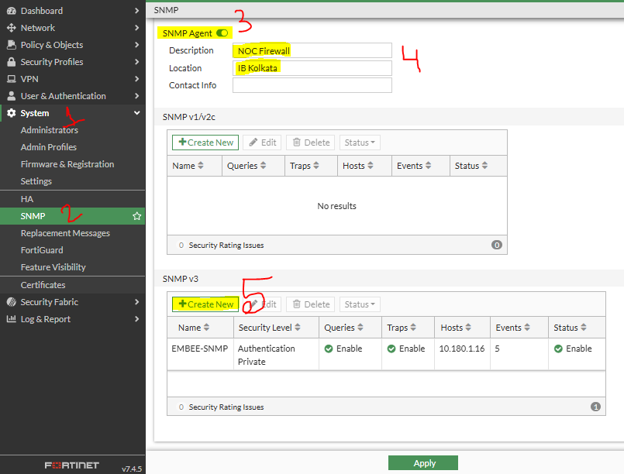
5. Verify SNMP Settings
To confirm the configuration, you can test SNMP by using an SNMP management tool like Site 24X7 or SNMPwalk.
CLI Configuration Example for SNMP v3
Here's how to configure SNMP v3 using the CLI:
